Kainan Dos Santos

Introduction:

Hide Assignment Information Instructions Make use of Excel charts, i.e., Spark line, tabular, pie chart. We could take dummy data for my results.

Methodology:

Generate a visual chart display using multiple tabs.

Conclusion:

To know one more thing that can help me in the future.

First graphic I put the numbers of perfume selling.

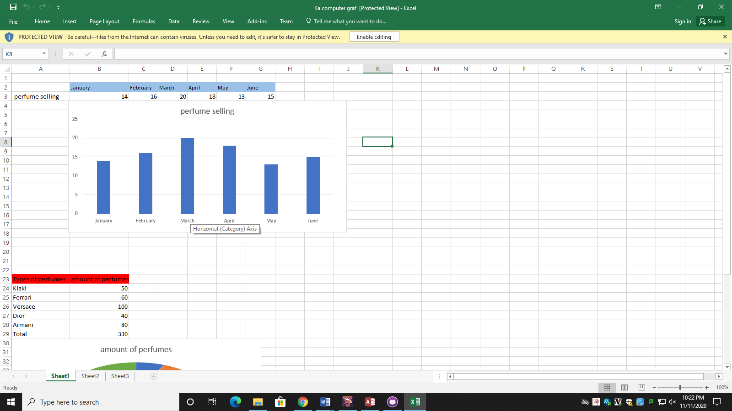

The second one I put the names and the amount of perfumes.

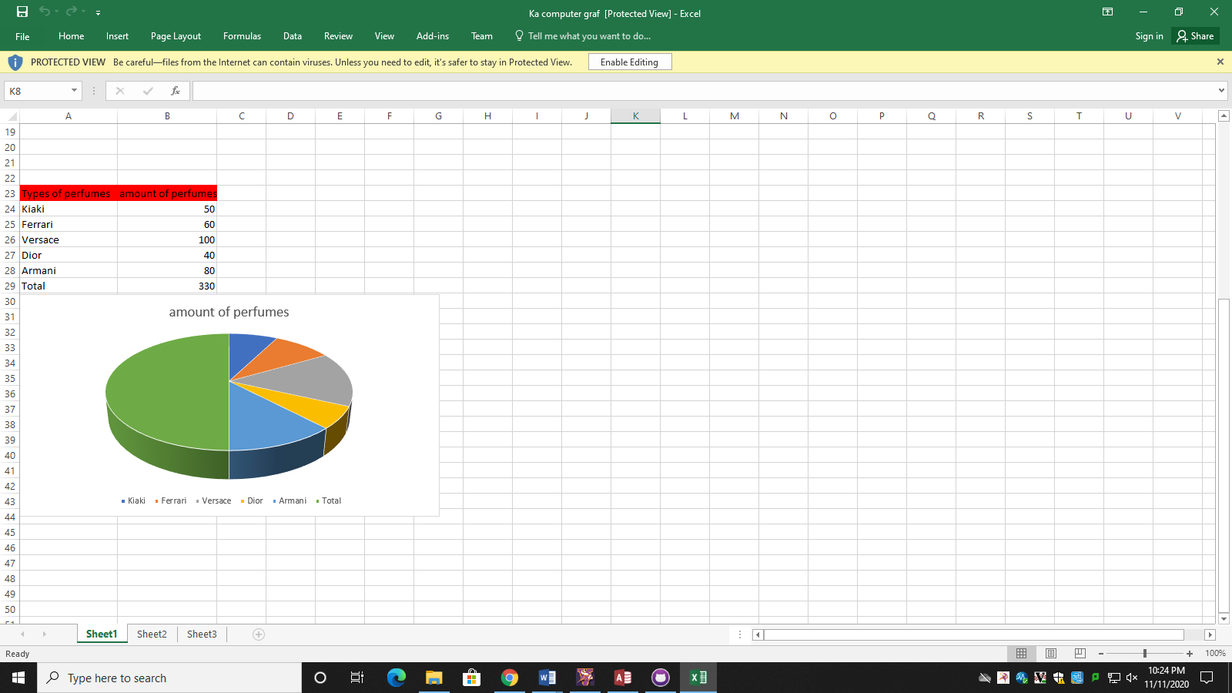

On this one I put the numbers of gols per practice of 3 players.

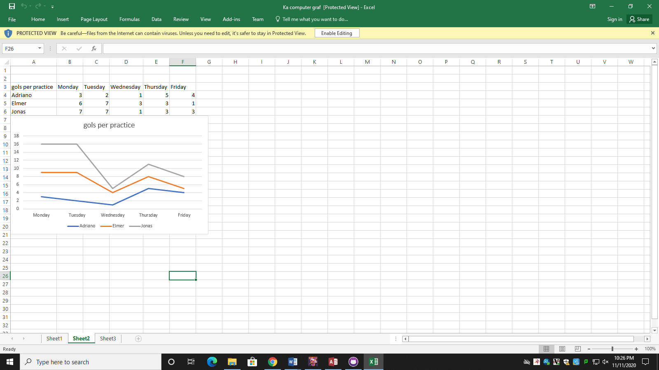

On this one I put the sales of cars and their years.

